FACE DETECTION ATTENDANCE SYSTEM
Python 3.14
Thejas Jagadeesh
St. Aloysius (Deemed to be University)

ABSTRACT.
This project presents a Face Recognition–Based Attendance System developed using Python and OpenCV to automate the traditional attendance process. The system captures real-time video through a camera, detects human faces using a Haar Cascade classifier, and recognizes individuals by comparing facial features with a pre-trained dataset. Once a face is successfully recognized, the system records the attendance along with the date and time, thereby reducing manual effort and human errors. The proposed system is cost-effective, easy to deploy, and suitable for controlled environments such as classrooms or laboratories. It also demonstrates the practical application of computer vision techniques in real-world scenarios.

SOFTWARES.
1)Python:
Core programming language, coded in VSC.
2)OpenCV:
Used for real-time video capture, face detection, and face recognition operations.
3)NumPy:
Provides efficient handling of image data and numerical operations used internally by OpenCV.
4)MySQL:
Used for storing attendance records such as name, date, and time.
5)Matplotlib:
For visualising attendance data

TEST1.
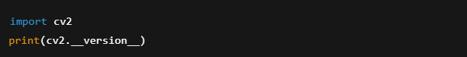
Returns the version no. of OpenCV used.
Currently OpenCv version 4.13.0 is used.
cv2 gives you access to:
- Camera
- Images
- Video
- Windows
- Keyboard input

TEST2.
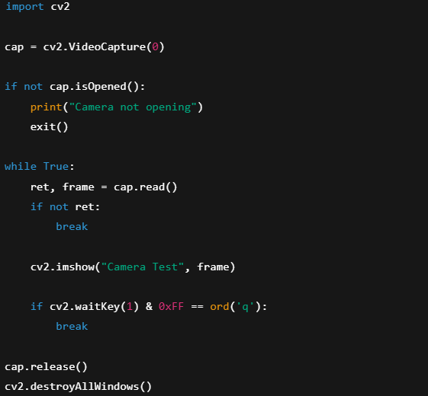
cap = cv2.VideoCapture(0)
“cap is the camera object in which the operation takes place, cv2 is the module, VideoCapture is the function that tells python that a video source is to be opened, (0) usually indicates the default video mode the device is currently using, in my case, it’s the default webcam.”

if not cap.isOpened():
print("Camera not opening")
exit()
“This code is used to check if the camera is working, sometimes the camera could fail or encounter some driver issues. cap.isOpened() returns True when the camera is open and ready to use, and returns False otherwise.”

while True:
“videos are just a stream of images flashing one after another, this loop runs infinitely to ensure each of those frames are read and processed. If there is no loop, it will just catch one frame which will be like processing one single photo rather than an entire video.”

ret, frame = cap.read()
“ret is a Boolean value which appears True when a frame is read and False otherwise. frame is the picture stored as a NumPy array, it contains pixel data in BGR format. BGR format is the way the color is coded in the image datastream (Blue first, Green second and Red third.)”

if not ret:
break
“if ret returns False, it stops the loop rather than continuing and displaying garbage data”

cv2.imshow("Camera Test", frame)
“it creates a new window called Camera Test and displays the particular frame within the loop, it updates the frame every loop iteration. In simple words it displays the camera, without this the camera runs but you won’t see anything”

if cv2.waitKey(1) & 0xFF == ord('q'):
break
“cv2.waitKey(1) just makes sure the system waits for 1 millisecond for a keypress and returns the ASCII code of the key if pressed. & 0xFF ensures compatibility across systems. ord(‘q’) is the ASCII value of the the letter q. this entire line basically says, if the user presses q, then exit the loop.”

cap.release()
“this releases the camera object, so that the camera doesn’t get locked. If this line doesn’t exist youd have to restart your pc to access the camera next time.”

cv2.destroyAllWindows()
“closes all OpenCV related windows.”

NOTES:
This script:
- Confirms OpenCV installation
- Confirms camera access
- Acts as the base for all future modules
  - Face detection
  - Face capture
  - Recognition
  - Attendance

